Scarlet Moon: A Complete Guide to the Main Storyline
- Written by Calm Fungus DDJoker
Update Notes:
The new version of Scarlet Moon cannot inherit saved data.
The new cover of Scarlet Moon changes with the stage of the saved data.
The Lord's Mansion is open all year round.
The Glazed Tower is open all year round.
The Moon Viewing Pavilion does not require inner elixirs for upgrades; you can go upstairs as long as your level is sufficient. There are a total of five floors, and the upgrade maze can be accessed on the third floor.
Clothing shares a single durability (previously, each piece of clothing had its own durability). If clothing is torn, it must be repaired. To change clothes, use the tent in your backpack. Clothing is in the precious items section, and the original fashion slot in the equipment section has become a gem slot. (To change clothes, select "Clear" in the clothing category to revert to the original state.)
The illustrations for the Qingluan and Spirit Fox pets have been updated (from juvenile to adult).
You can make medicine for mortals to obtain spirit stones, reputation, and merits. (Exchange at the Merit Hall in the Imperial City.)
The Blood God Pavilion and the Hehuan Sect are now open.
After completing the game once, all CGs will be unlocked, and you can inherit all items and cultivation to start a second playthrough.
The official version of Scarlet Moon includes four difficulty levels: Qi Induction - Easy: deals double damage, Liquid Condensation - Normal: deals 1.5 times damage, Dan Breaking - Hard: original damage, God Transformation - Hell: deals half damage. Difficulty does not affect the ending; it depends on personal choice.
Below is a guide for starting on God Transformation difficulty; other difficulties can be adjusted for comparison. (For Easy, just play casually without needing to refer to the guide.)

Beginner's Guide for Liuyun City (God Transformation - Hell Difficulty):
The Lord's Mansion can now be accessed every month, so at the start, exchange the Qing Shuang Dan recipe (Foundation Establishment Dan Recipe · A) in the Moon Viewing Pavilion using your mother's bracelet. Then, go to the Lord's Mansion to exchange for Qing Shuang Fruit, and head to the back mountain to grab a Dragon-Descending Vine before leaving. Buy five Light Spirit Herbs at the pharmacy, and then you can return to your room to refine pills. Additionally, you can collect spirit stones from the three rooms on the second floor of the inn. After breaking through, it is recommended to go directly to Glazed Village and spend 1000 spirit stones to exchange for silver to build a house. You can choose to: stay in the room and cultivate to max level, which will stabilize your level increase; or you can venture out (unlocking caves) to earn some spirit stones. Currently, venturing out only provides experience and is not as effective as cultivation. Afterward, you can head to the Black Jiao Secret Realm to start fighting. In the early stages, it is recommended to lose once in the non-H secret realm to trigger a plot event, allowing you to obtain the skill "Flame Cooking" for free at the Lord's Mansion. With the 900 base damage AOE skill obtained for free, you won't have to worry about early fights; losing to monsters in the first two layers won't break your character (if you're worried about losing, avoid fighting cultivators). Be bold in your fights. It is suggested to buy the Cloud Treading Boots from Hongxiu Workshop after clearing the first layer of the secret realm, and after clearing the second layer, the shop will change to buy the Haoyue from the Weapon Treasure Hall (if you haven't cleared it, don't go to the shop; if you can't win, you can buy embroidered shoes and green glazed items for transition). The second layer has some strength, so you can return to the Glazed Tower and the wilds of Liuyun City to clear small monsters; basically, two AOE skills will wipe them all out, and for low-health single targets, you can use whip techniques, although the damage is not high. Here, farm small monsters for materials to fully upgrade the Thorned Tail Whip and the Cloud Mist Shirt. The Cloud Mist Shirt can be upgraded to the Fire Spirit Armor and fully upgraded directly; materials can be purchased with spirit stones. This will allow you to fight the Qingluan. Pay attention to healing and skill cycles; healing should be sufficient to avoid being defeated in two rounds. After taming the Qingluan, directly feed all inner elixirs to the Qingluan for upgrades (it is recommended to equip the Tightening Spell). Now, the Moon Viewing Pavilion no longer requires inner elixirs for upgrades. To enter the fourth layer of the secret realm, you need to exchange for the Void Breaking Ring at the casino, and also exchange for 10 Dragon-Descending Vines to keep for Peach Blossom Village. As for the three special pieces of equipment that require luck fragments, whether to obtain them is up to personal choice. (The Jade Jiao Earrings from the first layer can be worn alone; it is recommended to get one early on, and it is suggested to wear it from the start when pushing the Black Jiao Secret Realm, as it significantly reduces pressure in the secret realm.) If you can't push through the Black Jiao Secret Realm, go out and fight small monsters, and do tasks at the Lord's Mansion (when accepting monster-fighting tasks, be sure to bring Cleansing Pills or learn Detoxification to enter areas without triggering poison CGs). Once you reach level 20, you can prepare to break through to the Golden Core stage. Use the previous monster elixirs to open a maze in the Moon Viewing Pavilion to obtain ancient coins (the maze does not require upgrades; the second-level maze is on the third floor of the Moon Viewing Pavilion, which requires level 30 to access). After exiting, go to the second floor of the Moon Viewing Pavilion to exchange for a Dan recipe, a Yunling Fruit, and a skill book for the first-grade Flame (single-target divine skill) (the Moon Mi Qu on the first floor is optional). Go to the second floor of the Lord's Mansion to exchange for six Morning Dew and one Solid Spirit Flower. Then you can refine pills to break through to the Golden Core stage. After reaching max level, clearing the Black Jiao Secret Realm will be effortless. After reaching level 25, you can go to the Glazed Tower to fight monsters every April and September to prepare for equipment upgrades. Exchange for the Tentacle Whip on the third floor of the Moon Viewing Pavilion, upgrade your armor to the Empty Mirror Armor, and in summer, catch a Nine-Tailed Fox (it has been tested that at level 20, using the Flowing Gold Whip MAX, Fire Spirit Armor MAX, Haoyue, Jade Jiao Earrings, and Cloud Treading Boots with a level 20 Qingluan can fight without healing; the Flame Cooking and whip skill cycles can be used directly). The Nine-Tailed Fox can challenge the Glazed Tower once it reaches level 30 (it is recommended to equip the Siming Ring). It is recommended to farm monsters beforehand to gather inner elixirs, enter the maze to obtain ancient coins, and directly break through to the Nascent Soul stage, then exchange for the Ice and Snow skill. For small monsters, use AOE spell cycles; for bosses, use Moon Mi Qu + Third-grade Flame + healing cycles. Remember to farm more materials for equipment upgrades; you can keep using the Tentacle Whip in the early stages, but armor must be upgraded. Thus, the beginner's guide for Liuyun City is complete.The following is purely the storyline process, not involving equipment acquisition and realm breakthroughs. For inquiries about pill refining materials, please refer to the "Item Query Table."
Regarding the game's Hell difficulty: testing shows that difficulty only affects Shangguan Yue and the pet's damage to monsters; the damage taken remains the same. The difference in damage between Shangguan Yue and monsters creates the varying difficulty. It is recommended to farm inner elixirs to feed pets, as pets are almost essential in battles. Now, the Moon Viewing Pavilion no longer requires inner elixirs for upgrades; you can go upstairs as long as your level is sufficient, which slightly reduces the pressure of needing inner elixirs.
My personal experience with the challenges of Hell difficulty is that leveling up and enhancing equipment are essential under this difficulty. When standards are met, fighting becomes a constant and sustained pressure; if standards are not met, it is basically impossible to win. It gives the impression that the difference between having and not having upgrades is minimal, but actually going back to fight previously defeated monsters shows that there is indeed an improvement. This feeling is primarily due to damage being halved and the defense providing too little damage reduction. Testing shows:
With 260 defense, damage taken is around 1100 when defending, and around 2400 when not defending.
With 697 defense, damage taken is around 800 when defending, and around 2200 when not defending.
With over 400 defense, the damage reduction is only about 10%, and it mainly relies on healing and damage skills in cycles, with no defense involved. Therefore, upgrading and enhancing armor is mainly to increase health, and the Jade Jiao Earrings are also essential equipment; otherwise, it is easy to be defeated in one hit.

Corruption Logic:
Corruption occurs as long as you have broken through a stage; even if you consume a Karma Dan to lower it, the opened stage remains. The plot direction in the Imperial City is determined by values, so monitoring values is useful. Some CGs are triggered by the corruption stage; consuming a Karma Dan to lower it is ineffective. If you have reached a certain corruption stage, it will trigger the corresponding plot CG. I have marked whether CGs are triggered by corruption value stages or numerical values in the "Complete CG Unlock Guide for Scarlet Moon."
Default Stage 1: 99 Evil Corruption Value to break through to Stage 2.
500 to break through to Stage 3.
1000 to break through to Stage 4.
1500 to break through to Stage 5.
Maximum limit: 2000.

Pets:
You need to find specific NPCs to unlock pet drops by talking to them during certain seasons. Defeating the pet allows you to capture it.

Qingluan:
On the swing above the fields in Liuli Village, talk to the girl (you can unlock the quest after the conversation) to learn that there is a Qingluan in the Abyss behind the mountain. Defeating it will obtain a spirit pet that is best sought after by new players. (Gender can be chosen)

Nine-Tailed Fox:
After clearing the third layer of the secret realm, during summer, next to the hermit’s house in Liuyun City, there is a male cultivator named Zhou Shan (36, 13). You will learn that a pure white fox will appear outside the city, and after defeating it, there will be a CG. After you defeat it, you'll obtain the Nine-Tailed Fox (gender can be chosen).

Qing Floating Cloud:
In autumn, find a female cultivator named Bai Xixi outside Liuli Tower. You will learn that a banished dragon comes to the island in the lake every spring. This is a divine pet, and the gender cannot be chosen; it defaults to female. Trade a City Lord's Order for a Dragon Heart, and feed it to her to help her advance.
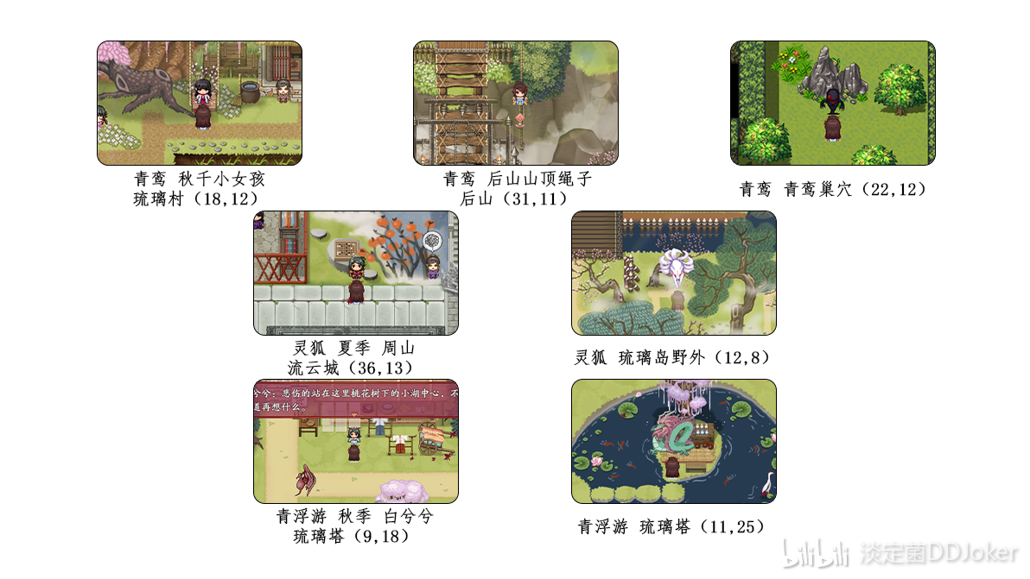

Post-Newbie Village Plot:
After finishing the fifth layer of the Black Molten Secret Realm, you can open the large map. Continuing with the main storyline, we arrive at Fenglin Imperial City and complete the plot. Pay attention when talking to Mo Xuan; this is a judgment node. If your corruption value exceeds 100, you'll enter the Resident Line; if it's below 100, you'll enter the Drunken Immortal Residence Line.

Black Molten Transformation Side Quest:
Mo Xuan will ask you to collect 1000 Qi and 10 Virtue each time. For those who want to see the CG without losing their virginity, directly interact with the NPC; there's no need to worry about how to obtain it. For those who don't want to lose their virginity, you can refer to my guide's table for coordinates where Qi refreshes. For Virtue, go do tasks with the Buddhist sect. After completing the Black Molten tasks five times, the Black Molten will ask you to seek the chance to transform in the Lost Marsh. After defeating the Wudou Sect leader and obtaining the altar usage rights, speak with the Black Molten. If the prince is alive at this point, he will help the Black Molten evolve without needing the Dragon Qi from Shangguan Yue. Also, the transformation only affects the ending storyline; if it is successful before entering the Fenglin Pavilion for the first time, it won’t alter the plot direction. (Teleporting to the Lost Marsh via the teleport stone is more convenient and faster than walking from the large map, as it teleports directly below the Wudou Sect leader; walking over would waste time being hindered by monsters at the marsh map's entrance.) Mo Xuan’s transformation greatly aids in the final battle with Feng Xi.
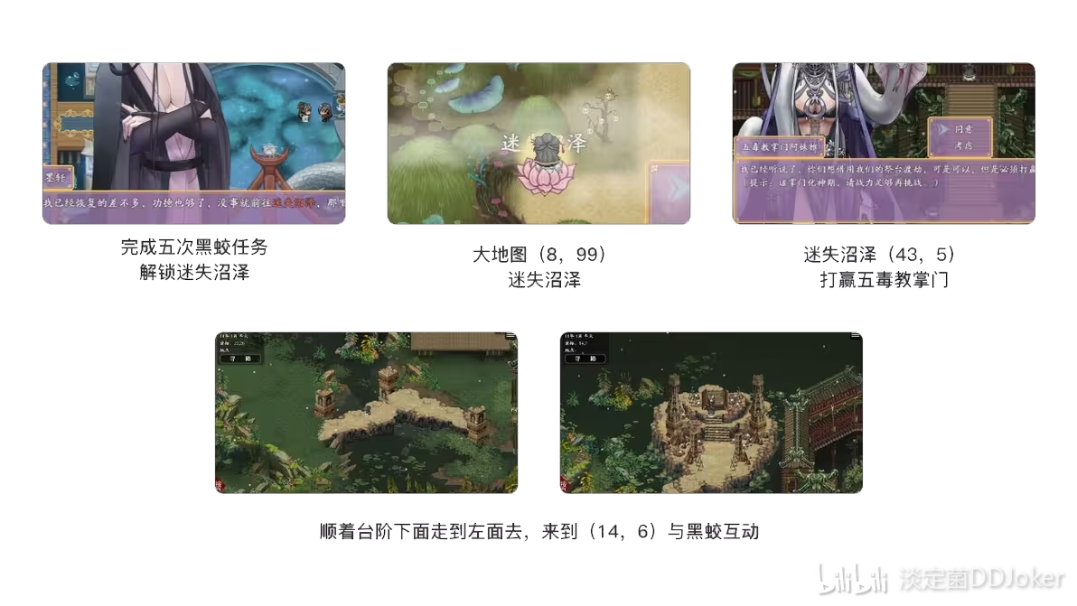

Large Map:
On the large map, there are various interactive icons, including this random event icon. The large map randomly refreshes several event points, featuring various secret realms and events.
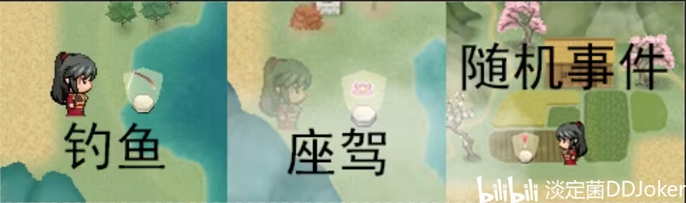
There is now a chance of encountering other types of secret realms in random events. For details about the things given by the Five Elements Secret Realm on the big map and the props that can be obtained by playing the Burning Sky Domain, you can check the "Prop Acquisition Inquiry Form".

Five Elements Secret Realm
The Five Elements Secret Realm will enter the secret realm of the monster in the corresponding realm based on Shangguan Yue's current realm. The best treasure chests will be the best treasure chests in Rounds 1-3, the ordinary treasure chests in Rounds 4-5, and the bad treasure chests after Round 6.
Underground spiritual veins obtain materials for strengthening equipment.
The Forest of Kun has obtained medicinal materials for breakthrough elixirs and recovery elixirs, while the bad treasure chest only has medicinal materials for recovery elixirs.
Deep Sea Phantom obtains props that enhance pet attributes.
Leaving the Fire Realm to obtain props that enhance character attributes.
Obtain monster materials that can be sold in the Burning Sky Domain in the Land of Desolation.

Burning Sky Territory
After refining the Void, you have to go to the place where you have to go. There are a total of three ways to play. You can dig for treasures and go to the Burning Sky Inn to find the waiter to buy treasure maps. There are ten random locations every month in the underground black market, and there are rounds of competitions in the competition. The more games you win, the more competition scrolls you will get. You can get skill books above the integration stage. There are auctions in the underground black market, and there are various materials and pill recipes for breakthroughs. After breaking through the calamity realm, you can still use Hongmeng Ziyue Powder to break through the stacked attributes.

brothel line
Back in the Fengchao Imperial Capital, we went to the slums, talked to the gangsters below, and prepared to sell ourselves to a brothel. Then pick up customers every day to gain reputation. You can also interact with NPCs in the courtyard and on the first floor of the lobby. As the evil value is gradually unlocked, give money + increase reputation. Pay attention to cuckolds who will lose their virginity. Vendors unlocked with reputation of 20 can buy plot props and charm potions, and buy the following three most expensive ones and four beauty pills. The two NPCs unlocked by the brothel reputation of 60 and 80 buy antique toys and monk elixirs and deliver them respectively. The clues will be unlocked. After unlocking the clues, go to the top card to ask. To enter the top card room, you need to buy a double-headed dragon and give it to the turtle man on the right to enter. After unlocking the two clues, you can ask about the whereabouts. However, please note that if the favorability is less than 100, you can directly enter the bedend without CG, so you need to give four beauty pills to the top card. Note that if you follow this line and fall into the third stage, you can come back and re-employ.
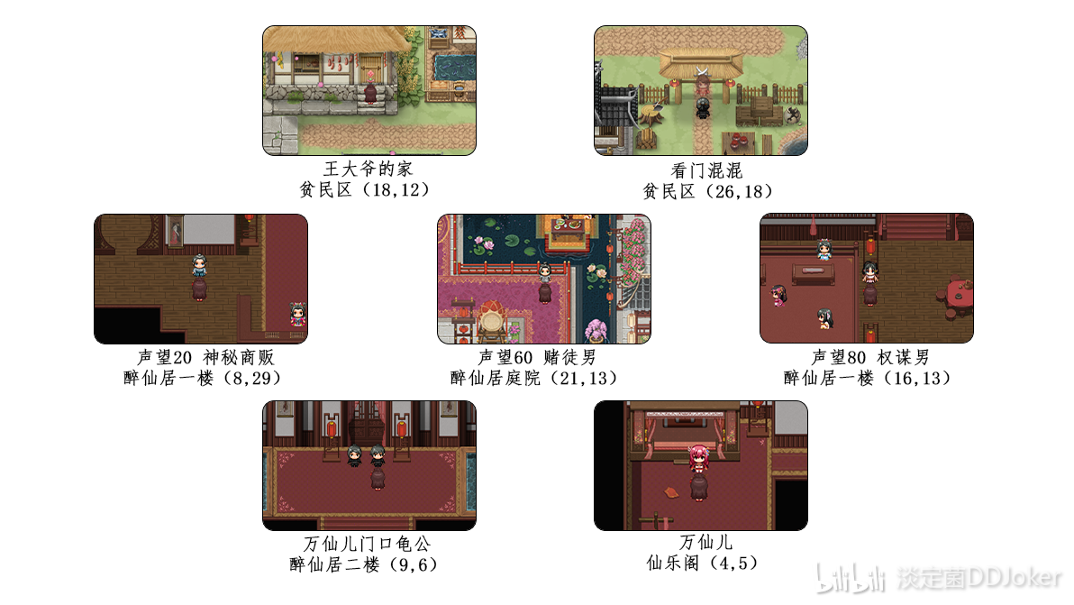

residential line
Returning to the Feng Dynasty Imperial Capital, we are going to the civilian area. We will first talk to Xinyue's relatives who were beaten, and then go to the slum area to find gangsters. Go straight in and kill fiercely. Enter the basement. The first semen you interact with is a direct suction, which will not break your virginity. The second one is the one with CG. It's over when the Pavilion of All Evils is destroyed at the bottom. Go back and continue talking to Xinyue's relatives. This time, you need to clean up the beggars. It's on the right side of the civilian area. After entering, go in and the second door from left to right is blocked by beggars. There is a black hole inside and you can interact with it to go down to the brothel line. Here you will be blocked by wooden boards. There is still a basement structure below, so just keep going in. The options for beggars and gangsters are the same, but the CG is different. The same thing is to go to the innermost part to trigger the end of the plot. Go back and talk to Xinyue's relatives again, and it's over.
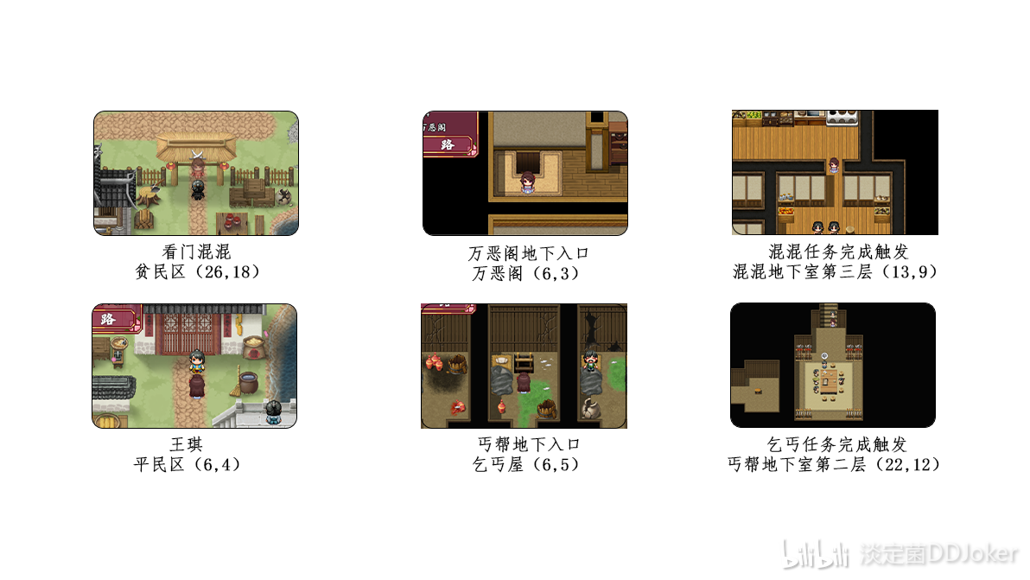

Peach Blossom Village
Both lines must return to the cave to talk to A Huan after finishing. Once the conversation is over, we can go to Peach Blossom Village. Upon entering the village, first talk to the village chief. Then, satisfy five villagers. The inn requires ten Dragonfall Vines; Yang Shuhua (31,20) needs ten grilled meats (dropped by raccoons); Wu Huahua (42,24) needs one pig, two chickens, and a jar of wine (can be bought in the imperial city, one chicken can also complete the task); Hong Shanshan (7,22) needs to finish chopping wood and washing clothes; for Yang Xu's family (14,28), just talk to the person inside. After satisfying the five villagers, return to find the village chief and request to summon the bird spirit pet. After the conversation, make sure not to foolishly go to sleep and jump to the moon. Go right to find Zhu Xiaohua (45,7), after the conversation, go down and talk to two NPCs for clues, first talk to Xu Changyuan (28,24). After accepting the task to defeat the drum, you will need to return to the back mountain of Liuli Village, do not foolishly look for the back mountain of Peach Blossom Village (there is no back mountain in Peach Blossom Village). We need to prepare one portion of rice, two chickens, and one incense. Then we can go and kill (21,3) (the drum has high health and damage, it is recommended to upgrade armor and use the Flame Whip technique to reach the second rank). After obtaining the Ziying Grass, return to talk; at this point, Zhu Xiaohua appears but will not help, so you need to talk to the second NPC Yang Weinan (23,28). After obtaining the clue, give Zhu Xiaohua 2000 spirit stones, and then you can enter the wormhole. In the wormhole, you cannot lose to the village chief; if you lose, you will directly enter bedend (the flowers fall, with CG). Remember to take the cursed ring from the chest in the cave (9,32), which has no attribute bonuses but can make clothes semi-transparent; you only have this opportunity to enter the wormhole. After defeating the village chief twice, the Peach Blossom Village storyline will be considered complete (the village chief's strength is similar to the drum, it is recommended to upgrade to the Nascent Soul stage and upgrade armor, frequently use the Flame Whip technique; this is a wheel battle system that does not restore status, so be sure to fill your status before the battle). Go to the village chief's house and talk to Zhu Xiaohua to get clothes. The item shop on the right is also open, and completing the task will also get you a witch's outfit.

Prince's Mansion Plot:
Next, return to the imperial city to find Xinyue's relatives, preparing to enter the prince's mansion to steal the prince's seal. After finishing the plot, directly work for 10 months and jump for 10 months; the vigilance of everyone is zero, and there are no guards at the door, so you can try to sneak into the Listening Snow Pavilion. There is a certain chance that there are no guards in the Listening Snow Pavilion (if there are no guards, you can talk to the prince and then unlock the investigation event); if there are guards, you cannot investigate, so return to the room and jump to the moon to continue. The seal is in the upper left corner, and the hidden room is in the lower right corner. (You can choose to enter this room now or be forced to see it after the prince dies in the magic world storyline; the two plots are different.) After finishing the plot, go to the military brothel on the big map; the wild monsters are not strong, just bring pets and kill them casually; only by defeating the boss monster can you enter the military brothel map. When entering the map, you must kill all the soldiers in the current map without missing any. After finishing the plot, go to the northwest military camp on the big map; the wild monsters are the same strength as those in the military brothel, and you must also kill all the soldiers in the current map to enter the military camp. After finishing the plot, there will be a branch again. Directly going to Fengling Pavilion leads to the magic world line. After completing the prince's survival plot, going to Fengling Pavilion leads to Jiangnan.
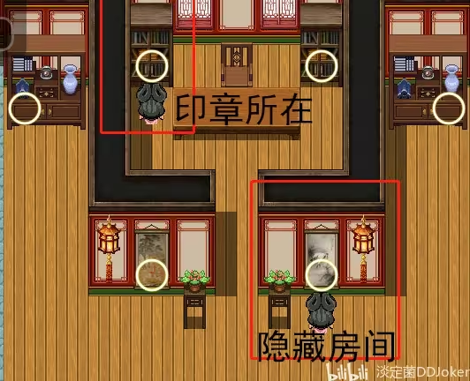

Jiangnan Line:
After finishing the plot of the military brothel and the northwest military camp, do not rush to Fengling Pavilion; go up in the imperial city to Longzhong Road, turn left to reach the Wang Taifu's mansion, and wear the dancer's outfit to accept the task. (Note: Only from here does it officially count as starting the Jiangnan line; the hidden room in the prince's mansion and Listening Snow Pavilion is not a necessary condition to unlock.) After finishing the plot, go down and directly walk left without going outside. Continuing inward will trigger the second plot (the plot of rescuing Yuwen Jingcheng can also be triggered after going to the magic world line; without the love maze plot, go directly to the princess's room to adopt in the cave). After finishing the plot, wait until July, and a small tourist group for "Love Maze" will refresh in the lower left corner of Longzhong Road. Go to participate, and then meet the prince; after finishing the plot, return to the Longzhong Road map, and go up, a new corner mark will appear, and this room is the princess's room.
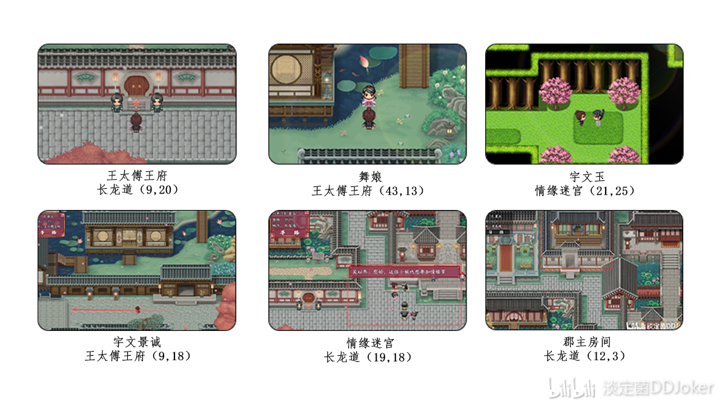
After finishing this plot, leave the prince's mansion and head to Fengling Pavilion, unlock the mechanism to go up. The prince appears directly to drive away the phoenix, and then arrives at the flower sea. Unlock Jiangnan (Yunyi Continent 88,55). After going through a period of pure plot in Jiangnan, you will be asked to find Jiang Ziya to obtain the God-slaying Whip.
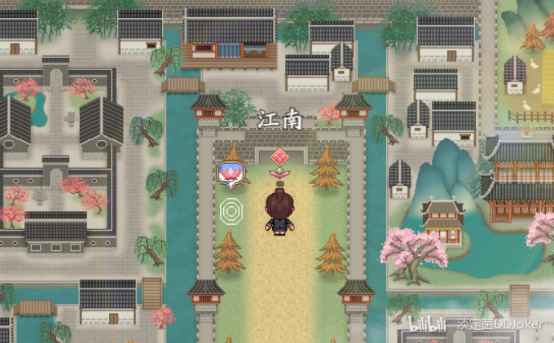

Magic World Line:
Directly go to Fengling Pavilion, enter the hall, catch butterflies and place them in the flower pot in the middle of the room, break the formation on the left to unlock the mechanism; after unlocking, a bridge will appear, walk over to the second floor, get killed by the phoenix, and be saved by Yuwen Yu. Yuwen Yu asks the butler to disband the prince's mansion and send a message saying he is dead, then takes Shangguan Yue to a certain place, sacrificing himself to use his past life’s power to resurrect Shangguan Yue. Under Mo Xuan's guidance, Shangguan Yue prepares to go to the magic world to obtain the truth (needs to give Mo Xuan ten Six Paths fragments). (If you haven't found the secret room before this, the main storyline will require you to find the secret room here). After giving Mo Xuan the fragments, we can go to the magic world, find the Demon Lord, who needs 50 merits, 30 merit fragments, and 10 golden lotuses (which can be directly bought in the magic world later) to help you unlock the Tianyuan Mirror to see the truth. After finishing the plot, he will also ask you to go to Buzhou Mountain to find Jiang Ziya to obtain the God-slaying Whip.

Final Battle:
There’s not much to say about Buzhou Mountain; defeating Jiang Ziya will allow you to obtain the God-slaying Whip. The upgrade materials for the God-slaying Whip are also sold by Jiang Ziya, and you can upgrade it there as well. After obtaining the God-slaying Whip, come to Fengchao Imperial Capital; you can enter the palace from the left side of the prince's mansion, and go straight to the emperor to stab him to death. In the magic world line, you only talk to Mo Xuan, while in the Jiangnan line, you will also talk to the prince. After the conversation, you can go to Fengling Pavilion again for a final showdown with the Black Phoenix Fengxi. In the magic line, you are forced to reach the Tribulation Realm to fight the Celestial Master, but Fengxi does not require it; at simple difficulty, level 60 Refining Void Peak with Black Flood Dragon can defeat it, while for hell difficulty, it is recommended to reach the Tribulation Realm and use Black Flood Dragon. If you lose the final battle, you will enter a bad ending (one bad ending for each of the magic and Jiangnan lines) and can challenge again; winning in the magic line leads to the Ascension ending, while winning in the Jiangnan line leads to a shameless ending with the prince in the three stages of corruption, and winning in the low corruption of the Jiangnan line leads to an endless pursuit ending; regardless of the line, reaching five stages of corruption leads to the Red Dust Immortal ending.
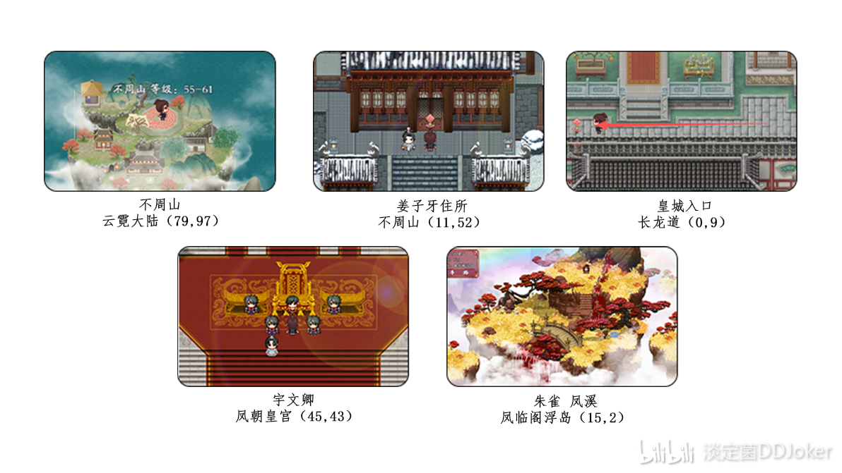

Magic Line:
Conditions for entering demonic state:
1. Before going to Fengling Pavilion (do not activate the Demon Realm and Jiangnan quests)
2. Heart Demon value reaches 1000
3. Black Flood Dragon transforms into a dragon
4. Fallen three stages
After meeting the above four conditions, return to the cave and a prompt will pop up asking if you want to enter the demonic state (note that after entering, you can only interact normally in Hehuan Sect, Blood God Pavilion, Demon Realm, and Ghostly Abyss; you cannot return to Immortal Spirit Garden).
After entering the demonic state, choose to join either Hehuan Sect or Blood God Pavilion. Once you join, you will be directly informed about how to use the Blood Fiend power and how to accumulate Blood Fiend value. Whether in Hehuan Sect or Blood God Pavilion, you can go to the Blood God Pavilion's pool to absorb Blood Fiend value, and both sides will inform you about slaughtering Liuli Island; then, when you ask for recommended weapons, they will tell you about the Ten Thousand Souls Banner in Ghostly Abyss (though it is said to be a weapon, it is actually a magical treasure, and this is not a prerequisite; you can directly go to Ghostly Abyss to find the old man with a smile). After that, there are no other main storylines; these are the three important main storylines. If you need to rest, go to your room in the sect, Room A, where you can refine pills and jump moon. After entering the demonic state, the big map still has demonic cultivators, and if defeated, you will be sold to the Spirit Beast Sect. After slaughtering Liuli Island and defeating the city lord, there will be an announcement across the region, and righteous cultivators from various sects will appear on the big map to fight you. In Ghostly Abyss, defeat the old man with a smile in the Soul Nurturing Pavilion, and you can go to the basement to obtain the Ten Thousand Souls Banner. Losing to righteous cultivators and the old man with a smile will not trigger defeat. The most important thing is to go to the Demon Realm; before refining the void, you can rely on your mother's bracelet and the sect's pharmacy's pill formula to break through. After refining the void, you cannot go to the Burning Sky Domain and can only obtain breakthrough formulas from the Demon Realm. Moreover, the subsequent equipment upgrades will mainly be spent in the Demon Realm. Hehuan Sect and Blood God Pavilion are not without their uses; you can go to the corresponding sect leader for free to learn skills of the corresponding stage. Additionally, the Blood Fiend value obtained from training in the Blood Pool of Blood God Pavilion or killing monsters can also enhance your attributes.
Go to the Demon Realm and directly seek cooperation with the Demon Lord to prepare for an attack on the upper realm. The Demon Lord requires you to try with him in the late stage of tribulation; if you win, you can proceed, but if you lose, you will become the Demon Lord's wife. After winning, you won't go immediately; the Demon Lord needs you to break through to the Tribulation Realm. At the peak of tribulation, you can ask him for a pill to break through to the Tribulation Realm and learn two skills from the Demon Lord. Although there is only one pill here, you don't have to worry about failure; failure does not consume it, only success does.
Once you break through to the first stage of the Tribulation Realm and everything is ready, there is no turning back; you will directly attack the Heavenly Court. We start on the far left, and after going down and then right, there is a platform shaped like a mountain character. You cannot enter the middle yet; you must first defeat the two Nine Heavens Xuan Nu on the left and right before you can go to the middle to find the Celestial Master Tianyan. After defeating these two Nine Heavens Xuan Nu, they will turn into treasure chests; the left one contains top-tier armor, and the right one contains a top-tier Beast Master Ring for pets. In the middle, finding Celestial Master Tianyan will lead directly to the ending, regardless of whether you win or lose. If you win, Shangguan Yue will control the entire continent, and Youwen Qing will be killed in the rebellion, causing turmoil across the continent, with only Mo Xuan and A Huan from Immortal Spirit Garden escaping disaster. If you lose, Tianyan will keep Shangguan Yue by his side, similarly becoming the Celestial Master's wife.
There are a total of three endings for the demonic storyline: becoming the Demon Lord's wife, becoming the Celestial Master's beloved wife, or seizing the Celestial Master's powers to control and destroy the entire Yunqi Continent.
Feiyue Immortal Journey Side Quest Full Process
- Calm Fungus DDJoker
Note: There are many NPC side quests that are short and have no CG, which are not written here. This only includes side quests in the sect area; the specific CG triggering methods in the respective areas can be found in the "Feiyue Immortal Journey Full CG Unlock Guide" table; please refer to it yourself.
Flowing Cloud City Side Quest:
Scholar Side Quest:
Next to the scholar's house in summer, there is a steward. Talking to him triggers the find wallet quest. Go to Liuli Village to first find the woman in the field, then go to the abandoned small house below to find the thief. Defeat him to obtain the money bag. (Before returning the wallet, if you break the pot above the small house, you will obtain the Scholar's Seal, which can be returned together to directly end the subsequent storyline.) After returning the wallet, if you are not in the Nascent Soul stage, you will be controlled. You can choose whether to go to the scholar's house at night; some storylines will close this event. If you are in the Nascent Soul stage, you will directly fight; if you are not in the Nascent Soul stage and are controlled, breaking through to the Nascent Soul stage will trigger a counterattack storyline. Losing will lead to bad ending - Flower Family Bride (with CG). Winning allows you to kill them all or keep the scholar as a dog (note that this will break your virginity). Be careful that if you are controlled before reaching the Nascent Soul stage and choose to go to the scholar's house while pregnant, you will be forced to give birth and then have your memory wiped, ending the side quest.
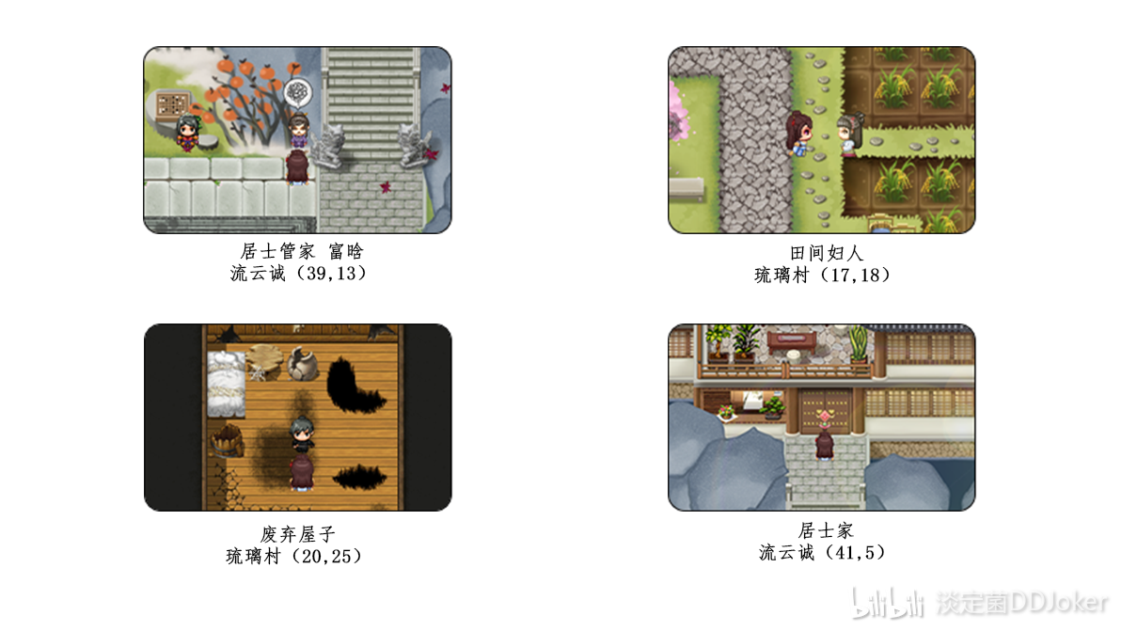
Time-Space Tunnel Side Quest:
In the year 10, there will be a small pop-up asking if you agree to add the jade slip as a friend. If you agree, go to Flowing Cloud City to find Ling Luo to accept the quest. The big map will then unlock the Mermaid Realm. Go down from the underground cave (to the right of the royal city on the sea), pass through two maps to arrive at the Mermaid Realm. Walk left into the main hall to directly ask the Mermaid King where the time-space tunnel is; the Mermaid King will tell you the big map coordinates (71,3) (this coordinate will not be displayed on the map if you do not ask the Mermaid King). Find the time-space tunnel on the big map; at this point, you still cannot directly tell Ling Luo and need to enter it and walk inside. After reaching the innermost part and talking to the person on the right, you can return to find Ling Luo to complete the quest.
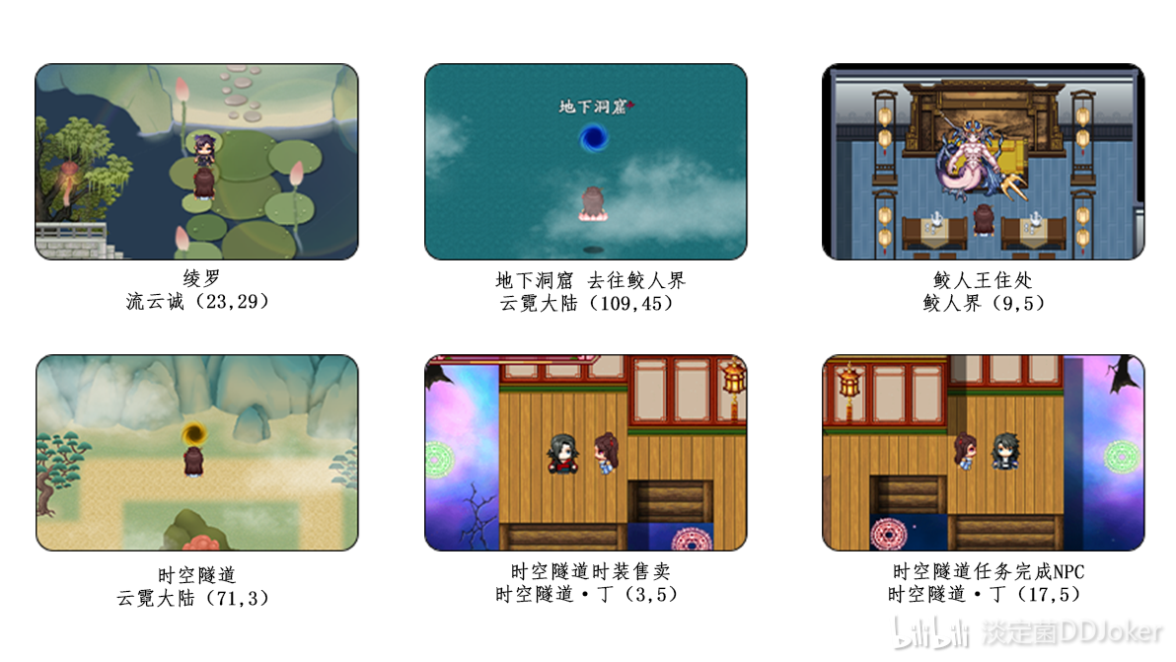
Buddhist Sect:
Buddhist Sect Demon Monk Discussion Side Quest:
Inside the Great Buddha Hall, in the 15th year, first talk to the little monk (18, 10) to obtain the secrets of Buddhism from him, and you need to give him sweet fruits in between. After the conversation, enter the disciple's room and talk to Jingwu (15, 5) to make him reveal secrets (you need to entice him here first before going to the lower right corner to entice him again; there will be a CG for the main plot). Then return to the Great Buddha Hall and talk to Wuxin (11, 4), give him 1000 spirit stones, and then enter the demon monk's room to discuss the Dao. If your Dao heart stability is less than 20 and your realm is below the Void Refinement (level less than 51), you will directly enter the defeat CG. You can go back to the underground prison, defeat three monks, and then take revenge. (I defeated them at level 50 with a tentacle whip, purple ghost armor, and an adult dragon girl using third-grade flames and the golden dragon god whip; relying on the dragon girl's skill for group healing.) If your level is high or your Dao heart is not less than 20, you can start fighting directly; you can fail once and then go to the prison as mentioned above to take revenge. You cannot lose the second time; if you lose, you will die directly at the hands of the demon monk (no CG). After winning, you will receive a relic and the basement key. Go to the upper left corner of the warehouse to use the key to open the dungeon, and directly fight three martial monks (the revenge after defeat is one by one). The strength of the martial monks is very low; even if you lose, you will not enter defeat and can return to full status to fight again. After defeating all of them, rescue the people, and after saving them, return to the Great Buddha Hall and talk to the little monk to complete the task.
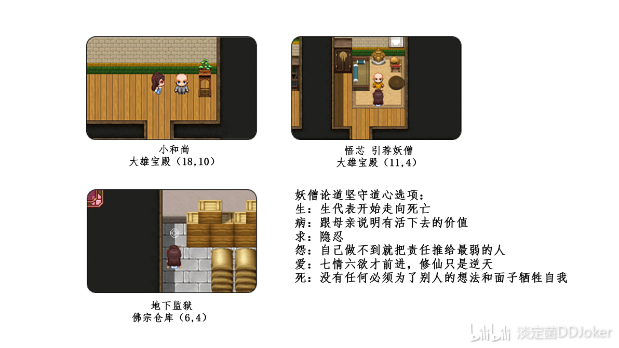
Buddhism Han Yu's Dao Partner Side Quest:
In the 29th year, go to the upper right corner of the Buddhist sect (27, 3) where the NPC Han Yu will appear. Increase your favorability to 50, and Han Yu will go to the Hehuan Sect. We need to use an excuse to enter the Hehuan Sect, go to the left side near the women's bath to trigger the plot, and then arrive at the secret realm. The secret realm is a map similar to "Ghosts Hitting Walls," and the route is left, left, right, left, up to reach the room where Han Yu is trapped. After interacting to rescue Han Yu, continue to increase favorability to 100. Han Yu will invite you to a lake near the Aotian Gate (Yunyi Continent (92, 8), Han Yu is blocked by a tree, but you can see him if you look closely), and after agreeing to interact, you will become Dao partners.
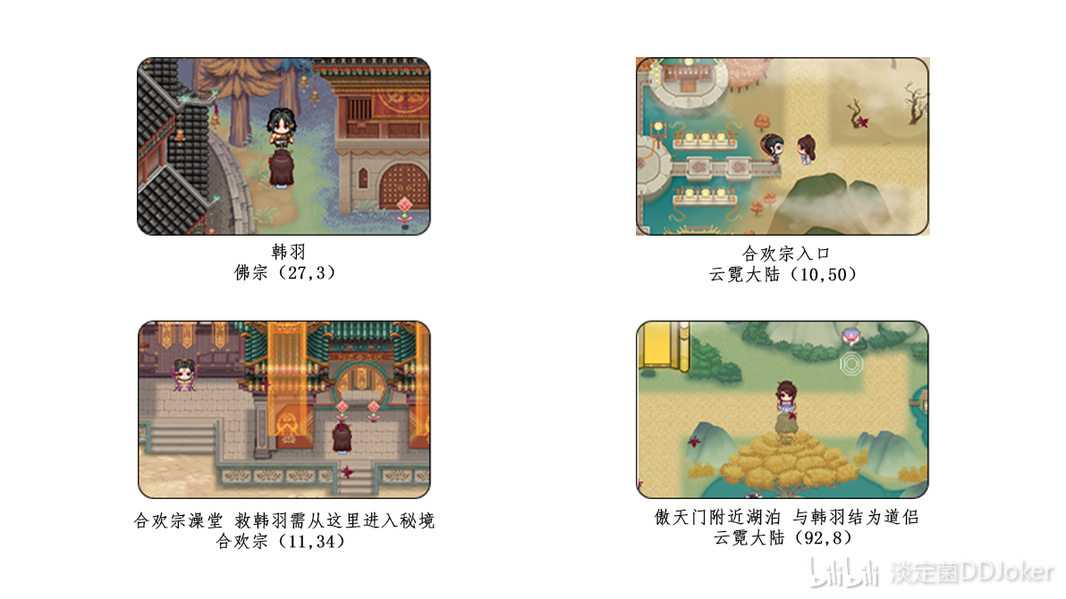
Buddhism Gu Xueying's Mermaid Side Quest:
At the Buddhist sect (21, 12), there is a believer named Gu Xueying. After talking to her, the side quest will start. In the 13th year, a light circle will appear not far to the right of the Buddhist sect on the big map (75, 47). After interacting, you will learn that Gu Xueying was pushed off a boat by her fiancé and is missing. After triggering this, you need to go to the imperial city to check the missing person notice (Fengchao Imperial City (15, 6)) to proceed to the next stage of the task; otherwise, you cannot trigger the plot by going directly to the mermaid realm. After seeing the missing person notice and triggering the next stage of the task, go to the mermaid realm and talk to the mermaid king to learn that he has rescued a girl. In the lower left corner of the mermaid realm, you can enter the mermaid mansion (5, 20) to interact with Gu Xueying. If your corruption value is ≥500, you can choose to let Gu Xueying stay and become a female mermaid; or choose to send her home. Later, you can see Ye Hao, who has become a beggar, in the slums (30, 4).
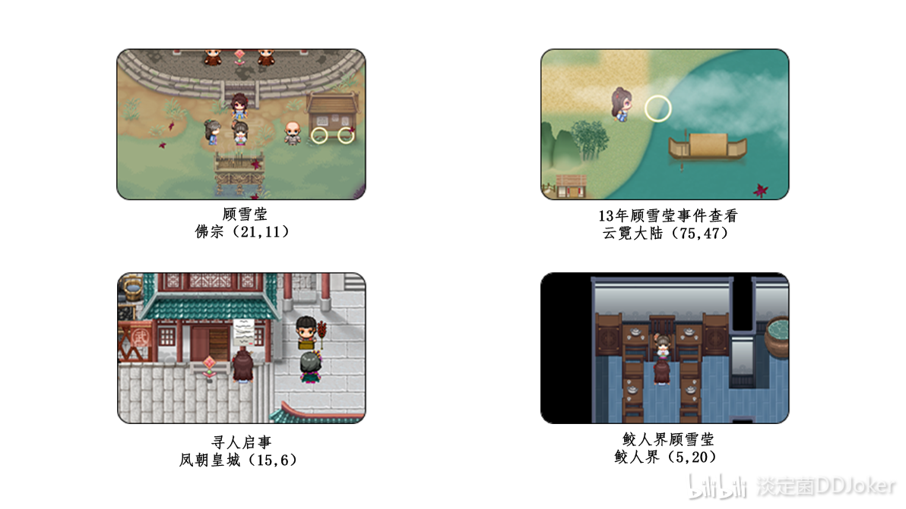
Faction Line: https://www.bilibili.com/read/cv20357062/?opus_fallback=1

Aotian Gate:
Aotian Gate Zhou Jingchu Dao Partner Side Quest:
The map of Aotian Gate is very large, with many peaks formed by swords on the back mountain. After reaching the Nascent Soul stage, you can talk to the sword spirit at night. The sword spirit says it looks down on the heavenly roots and wants to find the innate sword body. After talking to Zhou Jingchu, go find the sword spirit again. The sword spirit senses that you have previously interacted with the innate sword body and asks you to help find that person to pull it out. Next is the long and disgusting process of increasing favorability with Zhou Jingchu (because the map is large, it takes a long time to run while the favorability increases very little). After reaching 20 favorability, Zhou Jingchu will refresh in another location, and you need to talk to trigger the first event (sweet feeding). After triggering the event, return to the original place. At 40 favorability, the second event (sweet kiss) will trigger, and Zhou Jingchu will refresh on the back mountain. After triggering the second event, continue to return to the original place to increase favorability. At 70 favorability, the third event (making an enemy with Li Shuang) will trigger. After triggering, you can return to the back mountain to find the sword spirit to complete the task, giving 1000 spirit stones and 20 Dragon Breaker platform fragments. After that, you can continue to increase favorability with Zhou Jingchu to 100. When talking to Zhou Jingchu, she will invite you to the Peach Blossom Village at night and give you 100 spirit stones. At night in the Peach Blossom Village, you can choose to become Dao partners with Zhou Jingchu, and later you can cultivate together in the book (friendship level 60 and above is required to cultivate together with Zhou Jingchu).
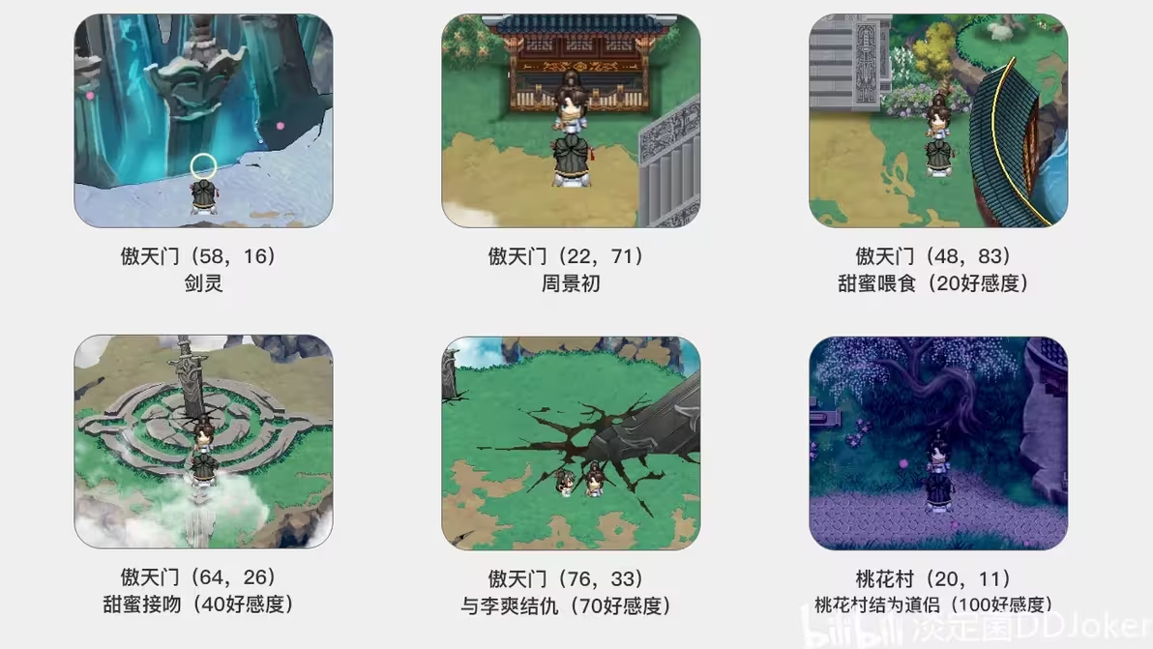
Aotian Gate Ancestor's Exit Plot:
After 35 years, the whole map will announce that the ancestor has exited the closed door. You can interact at the Aotian Gate Square. After three months of going out, a trigger event will occur on the big map where Li Qiankun will chase you. Defeating Li Qiankun will make you a dog, and if you lose the first time, Li Qiankun will take action (you will not enter a bad ending).
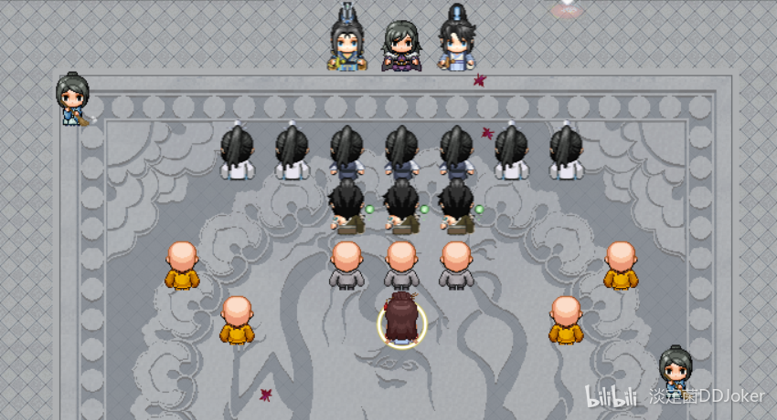
White Family Historical Branch:
In the 40th year, at Aotian Gate (97,109), NPC Bai Fenghua appears. Interacting with him during the second stage of his fall will prompt him to let you approach. After the interaction, he disappears. As you go up, his room opens; enter and choose to comfort him. In the final dialogue, inquire about your mother's background to obtain the magical weapon Qingping Sword. In the second month after the moon jump, he will be in bed inside the room. When you talk to him again, he will ask if you can forgive him. If you do not forgive Bai Fenghua, he will commit suicide. If you choose to forgive him, you can receive 1000 spirit stones each time you visit.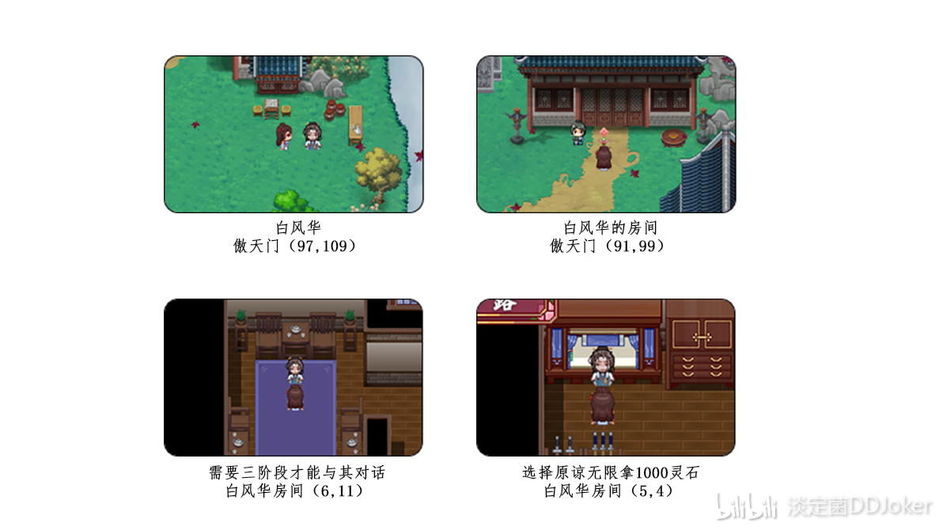
Gender-Swap Li Shuang Branch:
You need to complete the sect line to obtain the recipe for the Tianluan Daofeng Pill. After making three, go to Li Shuang's parents' room at Aotian Gate. There is a separate small room on the far left where you can interact with Zhao Meiyu. After giving her the three Tianluan Daofeng Pills, go to Li Shuang's room and you will find that Li Shuang has turned into a female. In the 40th year, during the fourth stage of her fall, go to the top left of the Burning Sky Domain (16,28) to find Du Yun hiding in Du Yue Pavilion. Enter and interact with Du Yun, and he will go to Aotian Gate to find Li Shuang. The condition to unlock Du Yue Pavilion is that Li Shuang must be female and in the 40th year; if she is in the third stage of her fall or below, Du Yun will not go to Aotian Gate to find her. After the interaction, there will be no changes that month; you need to jump months for Li Shuang's room at Aotian Gate to be cleared, and then you can trigger a CG by peeping at Du Yue Pavilion in the Burning Sky Domain.
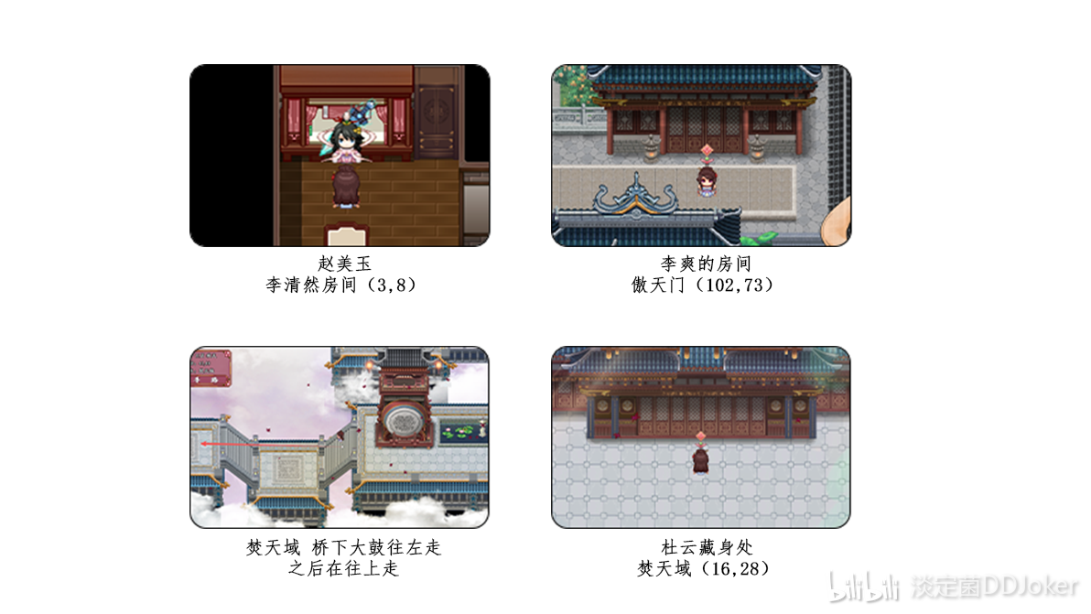
Fake Mother Flower Demon Branch:
In the 25th year, going to Fengchao Imperial City will automatically trigger an event where Shangguan Yue suddenly sees her mother's figure and then uses her divine sense to track her to Taohua Village. Arriving at Liu Feiyue's house (2,21), a low fall demon (with a maximum fall demon value of 99) can enter and talk to Feng Laifang, learning that it is a flower demon disguised as her mother, but Shangguan Yue cannot defeat Feng Laifang. At the second stage of the fall demon (with a maximum value of 500), you can use divine sense to perceive the union of the demon god and the flower demon, where the flower demon plants a peach blossom seed in Shangguan Yue, causing an abnormal state. At the third stage of the fall demon (with a maximum value of 1000), you can choose to engage with the demon god Feng Laifang, and at the fourth stage (with a maximum value of 1500), you can choose a 3P option, allowing free choice after joining.

Ghostly Abyss:
Ghostly Abyss Yandere Gu Yusheng Partner Branch:
Coordinates (28,27) for the gloomy man - Gu Yusheng. This difficult person initially does not speak and acts aloof, and you cannot see his affection level for you throughout. Interacting with him once a month should steadily increase your affection by 5 points. Winning in sparring does not increase affection but can earn spirit stone rewards. When Gu Yusheng's affection reaches 85, he will invite the female protagonist to Ghostly Grievance Pavilion. After that, the dialogue will not consistently increase affection by 5 points until it reaches 120, at which point Gu Yusheng will propose to be a partner with Shangguan Yue. There is no plot or interlude in between, and just chatting to increase affection can be somewhat dull; only during the third and fourth stages of the fall can you choose in-depth communication at Ghostly Grievance Pavilion to see some interaction.

Spirit Beast Sect:
Wu Youyou regains the Spirit Beast Sect branch:
In 2022, I met Wu Youyou at the entrance of the Aotian Gate, near Li Shuang's house (102,82). After talking with her, she asked for Shangguan Yue's help to take her back to the Spirit Beast Sect. If you refuse here for five months, you can see the follow-up in the right room on the first floor of the Royal City’s Drunken Immortal Inn (20,11). Choosing to help her return, you walk all the way to the headmaster's room of the Spirit Beast Sect, where you can choose to help Wu Youyou or Wu Mianzhi. If you help Wu Mianzhi, you can see the follow-up with Wu Youyou in the Beast Taming Room. If you choose to help Wu Youyou and defeat Wu Mianzhi, it triggers a CG where both of them end up in the nursery; after defeating Wu Mianzhi, the dialogue with Wu Youyou is also quite significant: if you choose to congratulate her on escaping suffering, you will only receive a one-time reward of spirit stones for completing the task. If you choose to thank her insincerely, you can threaten Wu Youyou to give you spirit stones every month. The second option means you can only let someone else take your place, and Wu Youyou will back down, allowing Shangguan Yue to be a nominal elder and give spirit stones monthly. If you challenge Shangguan Yue, the chief of the Spirit Beast Sect, Wang Shu, will become the headmaster (Wu Youyou's outcome is the same as helping Wu Mianzhi, and you can see it in the Beast Taming Room), and she will still be a nominal elder who can receive monthly spirit stones.
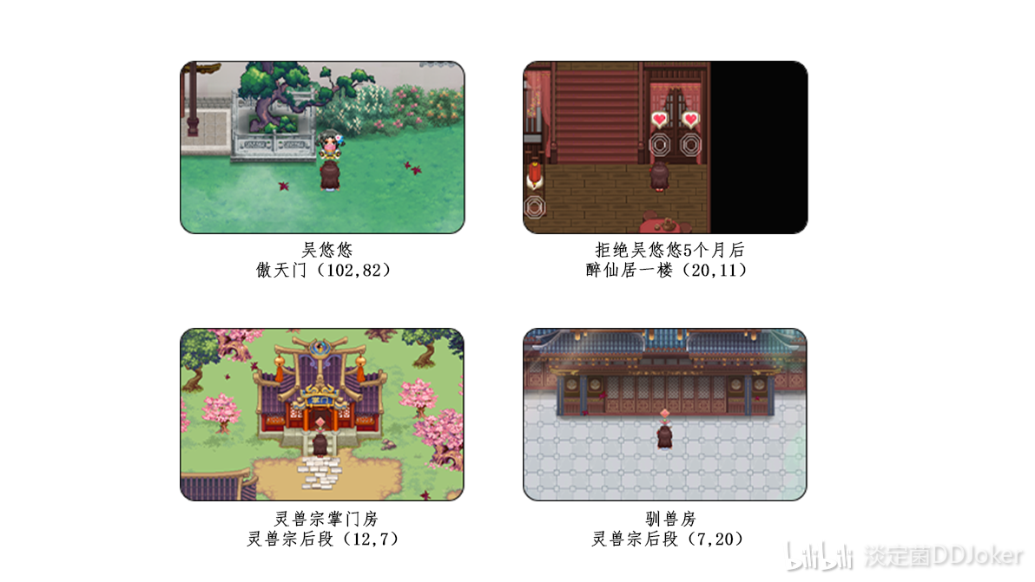
Sold to the Spirit Beast Sect as a nursery:
In 2019, purple-robed demon cultivators will spawn on the large map. After being defeated, you will be sold to the Spirit Beast Sect as a nursery. You need to reach a satisfaction level of 100 in the Spirit Beast Sect before you can lure someone to leave the cell. Note that even if you become an elder first, you must still reach a satisfaction level of 100 the first time you enter; only on the second entry can you use the elder's movement technique to choose a spirit beast or leave directly.

Flame Heart Pavilion:
Strictly speaking, the Flame Heart Pavilion is not a side quest, as it does not have a continuous storyline from beginning to end, nor does Shangguan Yue play a decisive role in the story. You need to complete the sect line after the destruction of Lingxiao Palace to join (it seems to be the only righteous sect you can join). After joining, the gameplay involves taking tasks, completing them, submitting tasks, and exchanging items daily while interacting with Elder Wulan (4,17), the headmaster, and Elder Wannian to increase affinity. When the headmaster's affinity is ≥20, you can interact with the headmaster in the room to trigger the Flame Heart Pavilion's martial arts storyline; when the headmaster's affinity is ≥40, in autumn, you can interact with An Lingyue at Fenglin Royal City (6,8) to trigger the temple fair storyline; when the headmaster's affinity is ≥60, in spring, you can trigger the spring drinking storyline in the headmaster's room; when the headmaster's affinity is ≥80, you can trigger the hot spring storyline in the headmaster's room; when the headmaster's affinity is ≥100, entering the headmaster's room triggers the elder's medicine testing storyline. After triggering this storyline, if Wulan's affinity is ≥80, entering the headmaster's room triggers the elder's draining storyline. If Wulan's affinity is ≥80 before triggering the elder's medicine testing, both storylines will trigger in sequence. The storyline with Elder Wannian is separate and needs to have enough affinity; you must go to her room's door at night to trigger it. If Wannian's affinity is ≥30, the first part of the storyline will trigger; if it is ≥70, the second part will trigger. Note that if you go directly to 70, you will only see the second part of the storyline and not the first part at 30. Moreover, all CGs in the Flame Heart Pavilion can only be triggered once.
